**Site Name:** Bountiful Foods

**Site logo:**

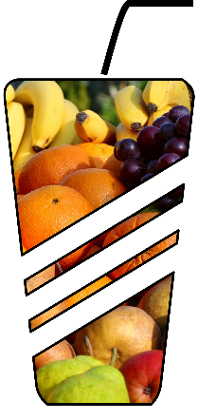

**Site Purpose:**  
The purpose of Bountiful Foods is to attract and retain customers by

offering a wide selection of fresh, healthy fruits and providing a

convenient and enjoyable experience. The main goal we aim to is:

Proving that eat healthy is not expensive as all people think and it

can be an enjoyable experience as well as other food can be.

**Target Audience:**

1. Health-conscious. People who are interested in maintaining a

healthy lifestyle and want to incorporate fresh fruits into their

diet.

2. Fitness. People who are into fitness and exercise and are looking

for healthy, natural sources of energy and nutrition

3. Families. Parents who are interested in providing healthy and

nutritious food for their children and incorporating more fruits into

their family's diet.

4. Vegans. People who do not eat meat or derivatives of it, they enjoy

cooking, experimenting with new recipes, and exploring different types

of fruits to add on their diet.

**Personas 1:**

Raul: I am committed to maintaining a healthy lifestyle, I am always

on the lookout for fresh and nutritious foods. When I discovered a

webpage that specializes in selling a wide variety of fresh fruits, I

was thrilled. The webpage not only offered a convenient way to

purchase high-quality fruits, but it also provided valuable

information about each fruit's nutritional benefits and preparation

tips. Since then, I have become a regular customer and have been

delighted with the quality of the fruits and the exceptional customer

service.

**Personas 2:**

Samantha: My family and I love to try new recipes and experiment with

different types of fruits. However, it can be challenging to find a

wide variety of fresh fruits at our local grocery store. This webpage

allows us to explore new recipes and get creative with our cooking

while ensuring that we are incorporating plenty of healthy fruits into

our diet.

**Site Map:**

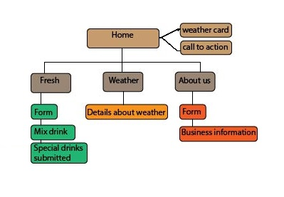

**Color Scheme**



Typography

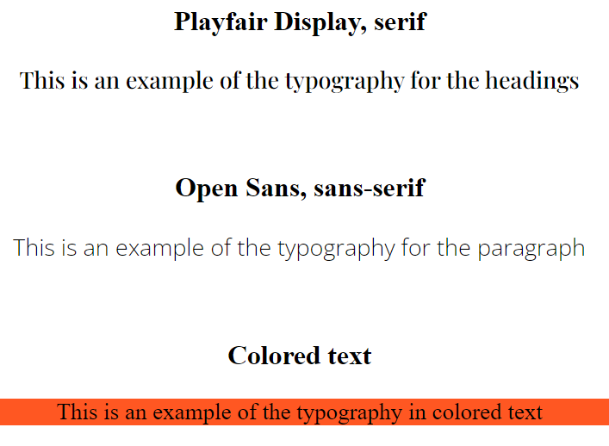

**Wireframe Sketches**

